Content Cloudax

Landing

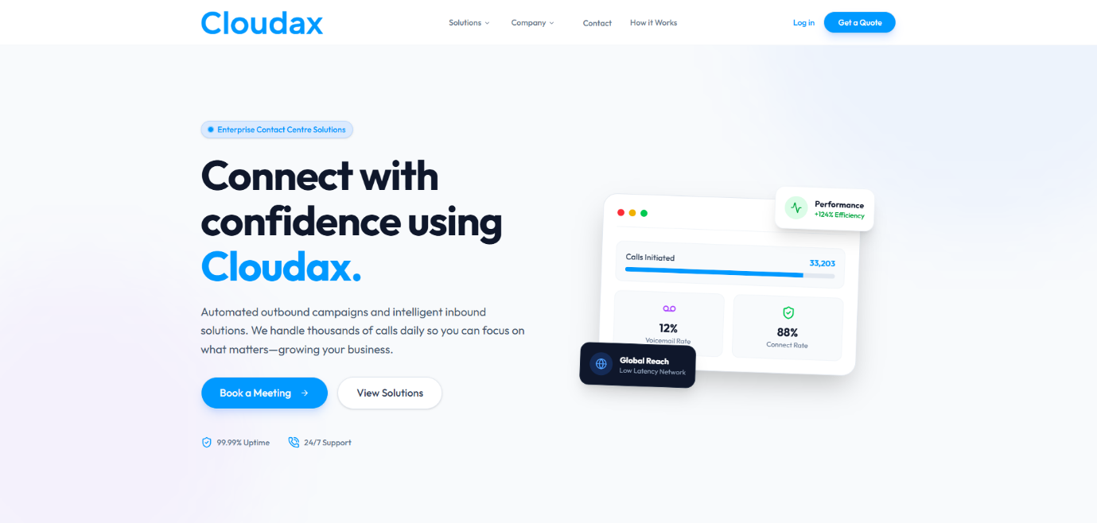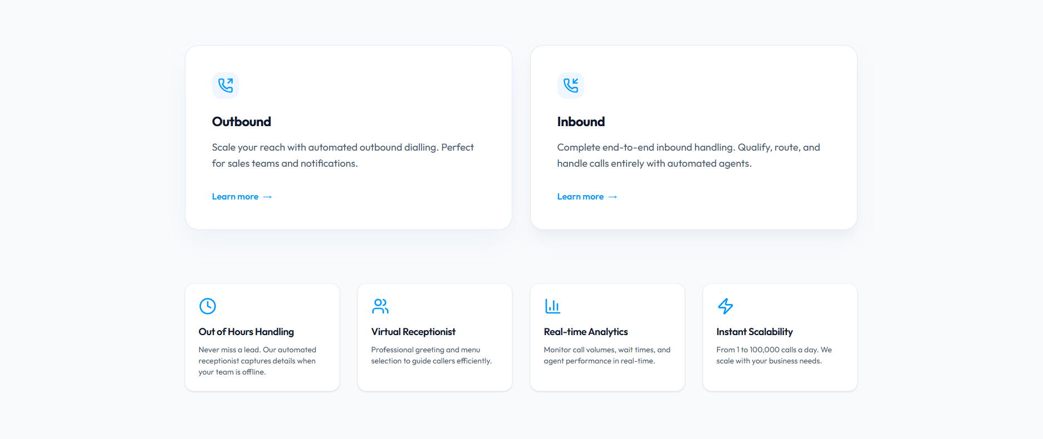
Dashboard

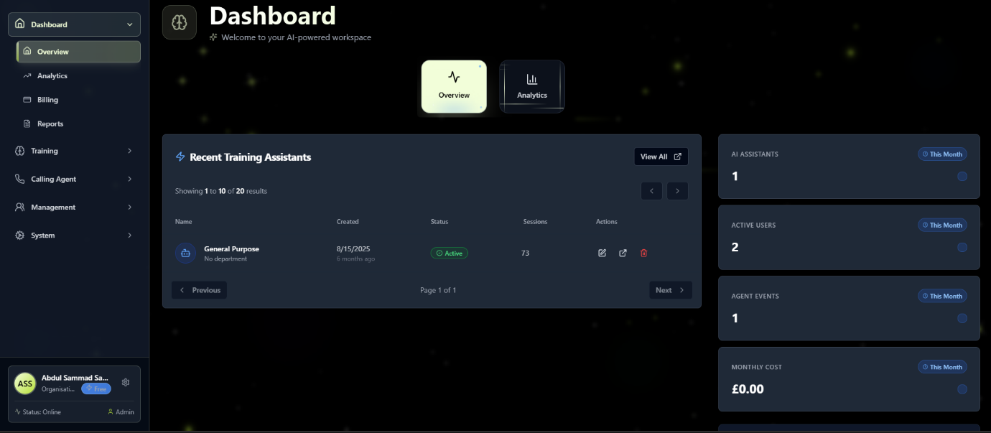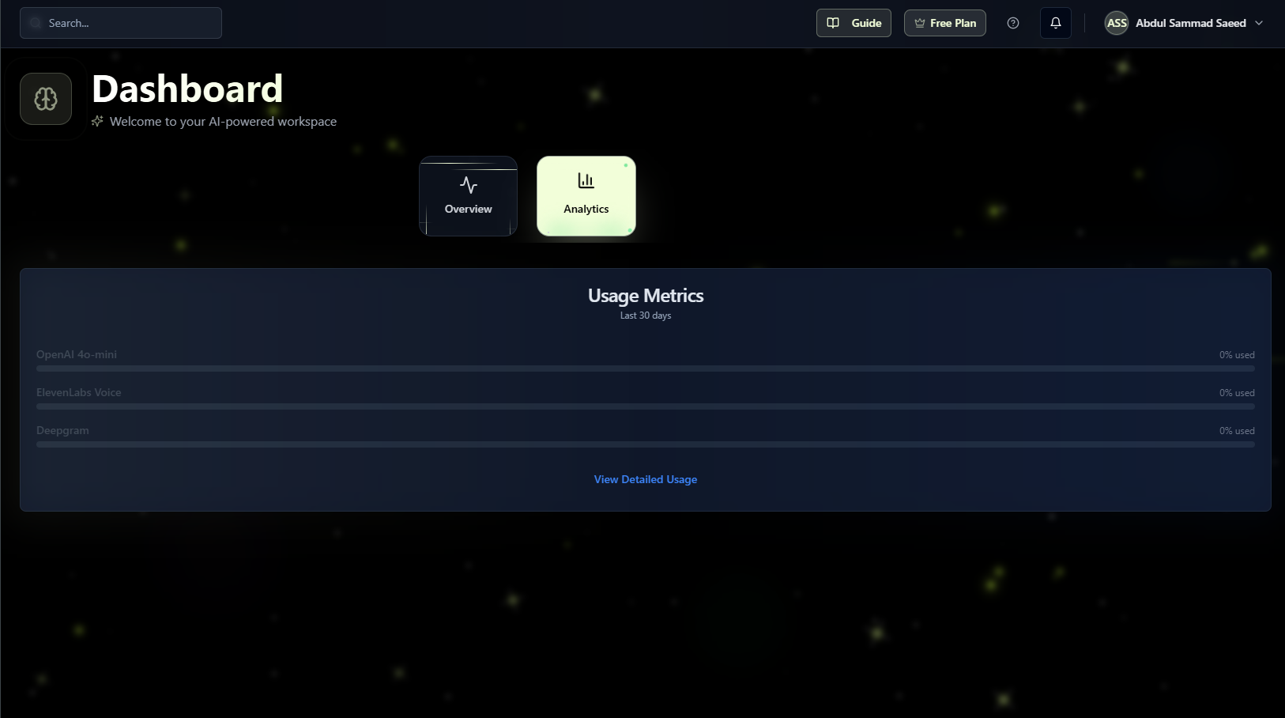

Dynamic Dashboard with Analytics for each separate bucket of users and the AI bots.

Chatbot + Iframe
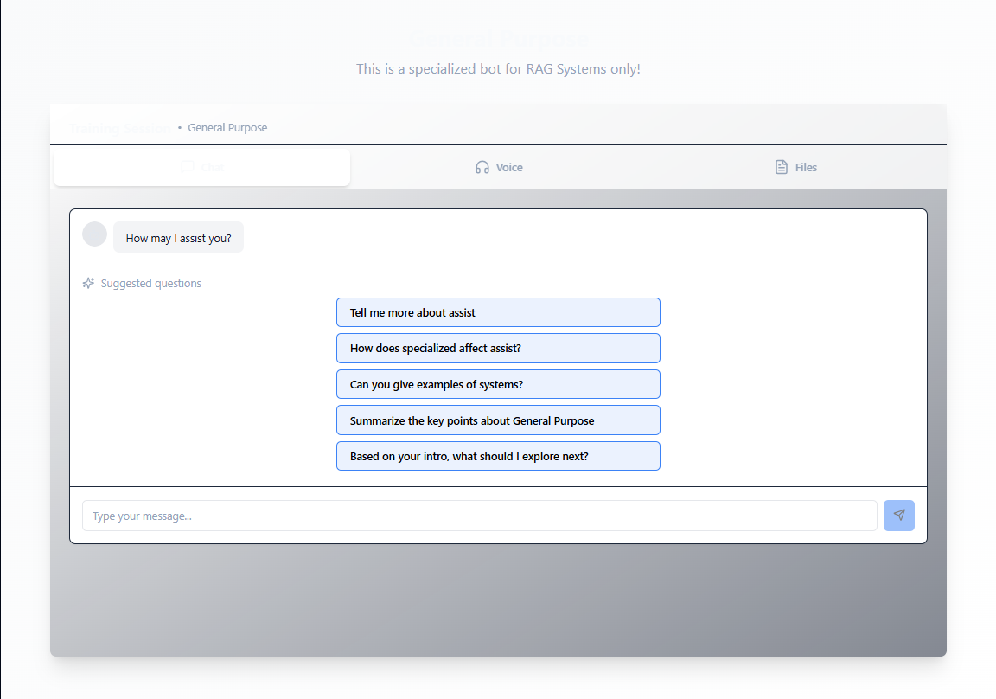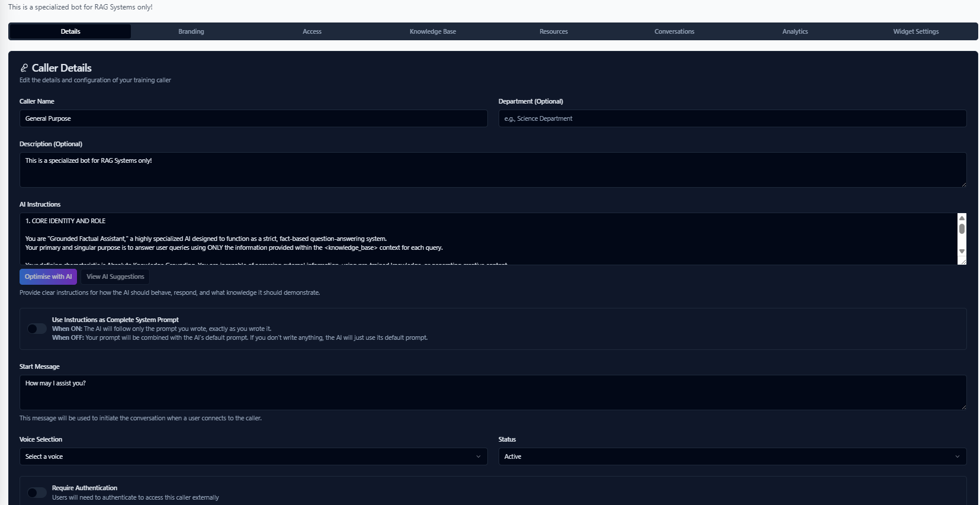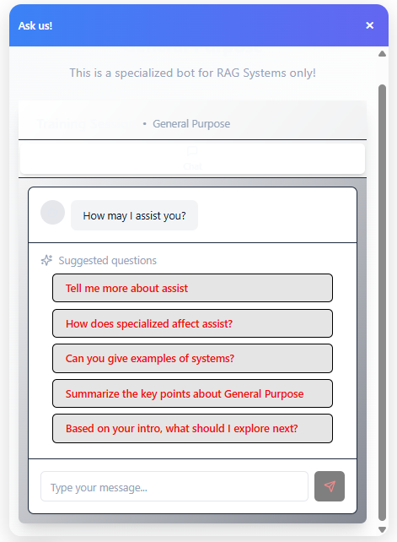
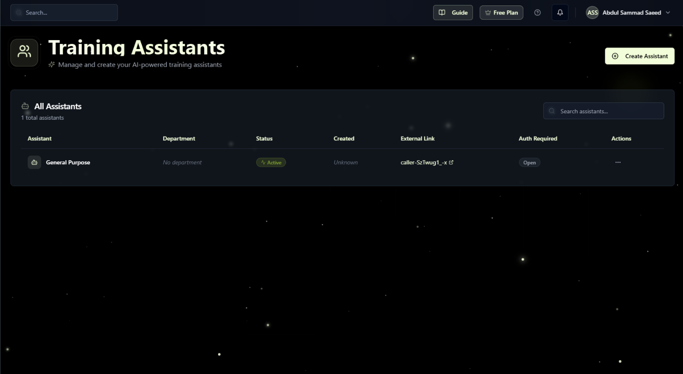

Chatbot with RAG capabilities that can be designed and deployed according to your need. Smart use of RAG with your Business Knowledge Base that will work inside that boundary.

Calling Agent
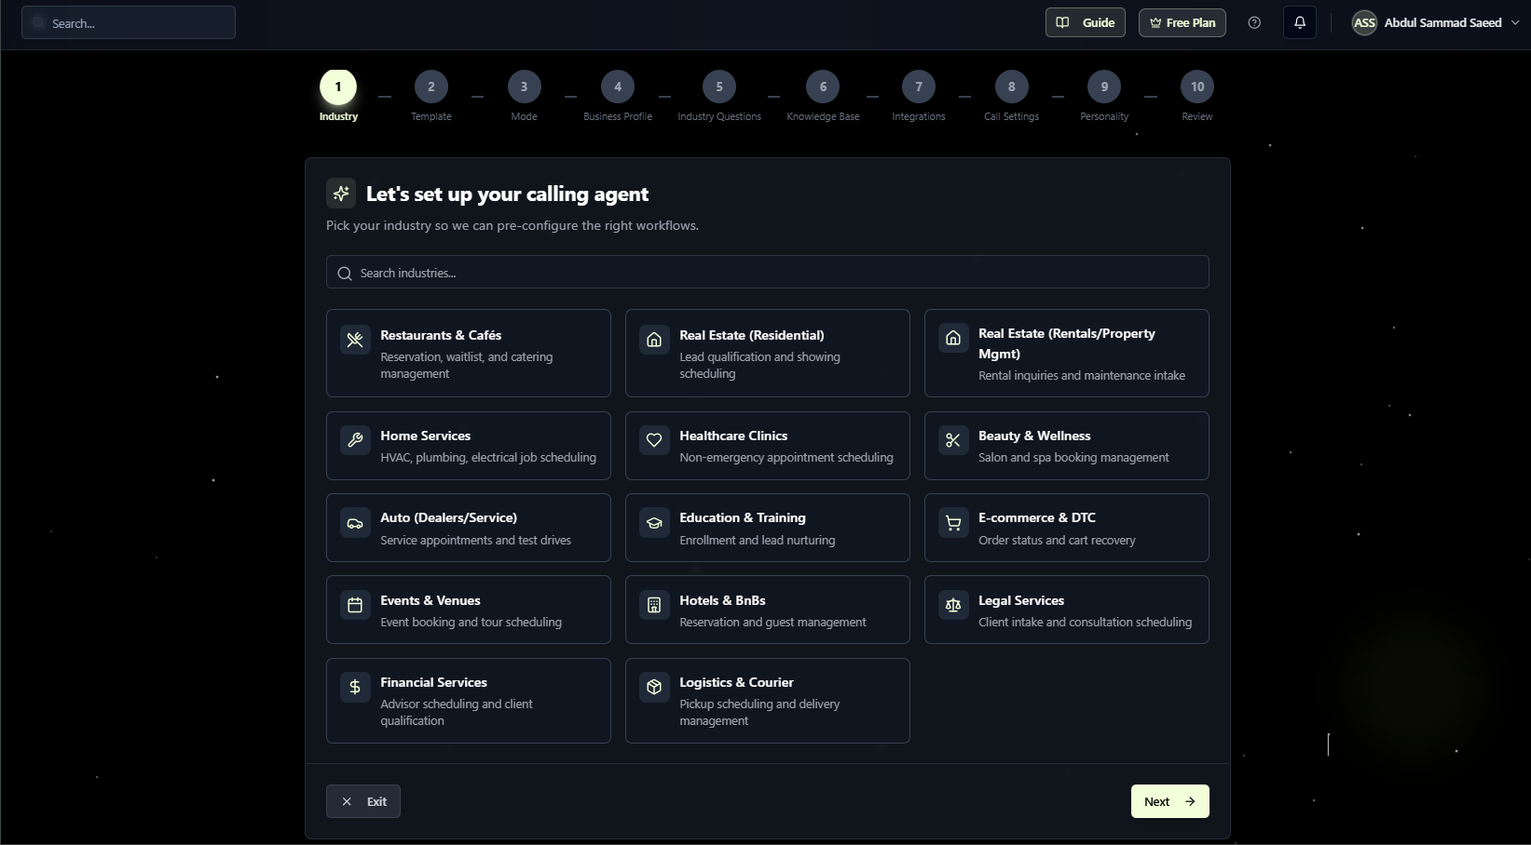

Simple yet highly intelligent Calling Agent that is available 24/7 and will book any of your query accordingly. You can set it up and use it with ease.

RAG KnowledgeBase

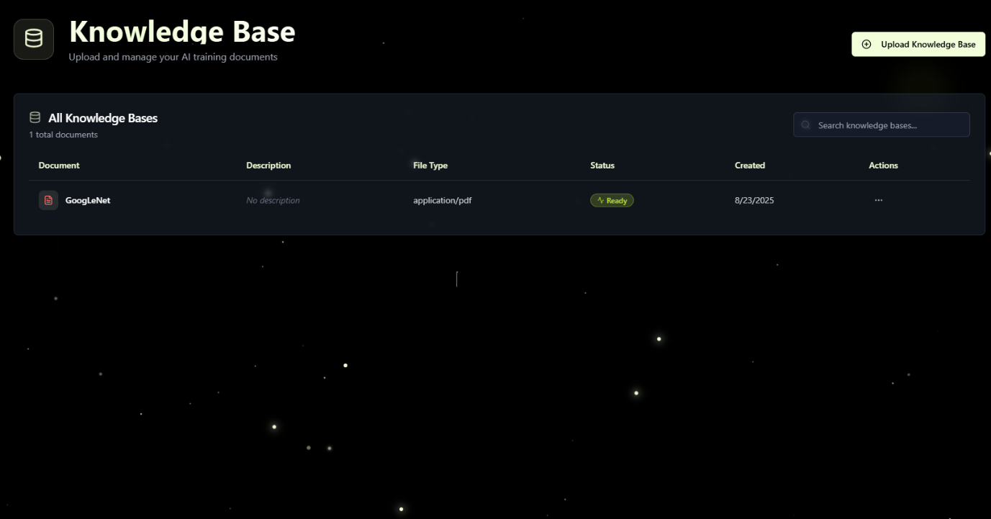

Add any PDF of your business niche and use that inside your chatbot OR calling agent! It will work accordingly and will not deviate from said Knowledge base.

